WordCount

Software Requirements Specification

0.0.2

June 17 2016

Steven Mayner
Lead Software Engineer
Bentley Kang
Software Vice-Engineer

Revision History

Date | Description | Author | Comments
6/14/2016 | 0.0.1 First Draft | Mayner & Kang
6/17/2016 | 0.0.2 Rough Draft | Mayner & Kang

Document Approval

The following Software Requirements Specification has been accepted and approved by the following:
Signature | Printed Name | Title | Date
 | Eduardo | Stakeholder
 | TJ | Teacher’s Assistant

Table of Contents

Revision History ii
Document Approval ii
1. Introduction 1
1.1 Purpose 1
1.2 Scope 1
1.3 Definitions, Acronyms, and Abbreviations 1
1.5 Overview 1
2. General Description 1
2.1 Product Perspective 1
2.2 Product Functions 2
2.3 User Characteristics 2
2.4 General Constraints 2
2.5 Assumptions and Dependencies 2
3. Specific Requirements 2
3.1 External Interface Requirements 2
3.1.1 User Interfaces 2
3.1.2 Hardware Interfaces 2
3.1.3 Software Interfaces 2
3.1.4 Communications Interfaces 2
3.2 Functional Requirements 2
3.2.1 Input Text 2
3.2.2 Counting System 2
3.2.3 Calculations 3
3.2.4 Output Report 3
3.2.4 Error Handling 3
3.3 Use Cases 3
3.3.1 Use Case #1 3
3.3.2 Use Case #2 3
3.5 Non-Functional Requirements 3
3.5.1 Performance 3
3.5.2 Reliability 3
3.5.3 Availability 3
3.5.4 Security 3
3.5.5 Maintainability 3
3.5.6 Portability 3
3.8 Logical Database Requirements 4
4. Analysis Models 4
4.1 Sequence Diagrams 4
4.3 Data Flow Diagrams (DFD) 4
4.2 State-Transition Diagrams (STD) 4
5. Change Management Process 4
A. Appendices 4
A.1 Appendix 1 4
A.2 Appendix 2 4

1. Introduction

Purpose
This SRS is presented for the usage of the Lead Software Engineer and Vice-Engineer to organize and clearly state the requirements of the WordCount project to stakeholder(s) to ensure a satisfactory deliverable product.

1.2 Scope
The ultimate goal of this project is to produce WordCount, a Python program operated via the command line, for use in analysis of student essays in a digital format. WordCount takes a text file as input and reports the average number of words used per sentence as output. The application of this is to facilitate the teacher’s students in writing shorter, more concise sentences as part of writing their essays.

To succeed in this goal, WordCount must be accessible and easily used by college students and faculty with little or no technical experience, require little or no maintenance, and maximize compatibility across platforms and operating systems.

1.3 Definitions, Acronyms, and Abbreviations
Counted word: For the purposes of the WordCount project, a counted word is a word longer than three letters. Only counted words are considered for the total sum used in the average formula.

Sentence: For the purposes of WordCount, a sentence is defined as a string of ending in a period, exclamation point, question mark, comma, colon, and semi-colon.

1.5 Overview
Following this section is a description of WordCount’s traits as a program and a product, followed by more specific elaboration on the use cases and requirements expected of the program, and finally is a brief discussion of how this document itself will be updated.

2. General Description
The primary factor in the project’s functional and non-functional requirements is the varied and unpredictable nature of the user. Access to other software/hardware and technical skill cannot be assumed and must be accounted for. The user base is very large, and may include individuals requiring accessibility aid.

2.1 Product Perspective
The Microsoft Office Word have words counter on the bottom left corner. It counts pages, words, characters, paragraphs, etc. However it doesn’t show length of sentence and average length of sentence. Also Microsoft Office Word work in real time. However our program will not run in real time. The user will use the program when they are finished with the report. And the program will only output the average length of sentence. And only able to input .txt report.

2.2 Product Functions
The software will count the total words from the report and divide by the total count of sentences, and it will display that number. The product will also be able to process files individually or in batches, calculating the average across all input files.

2.3 User Characteristics
The user(s) will have an unknown level of technical experience. English proficiency is assumed.

2.4 General Constraints
The system must be compatible with accessibility devices such as text-to-speech and impaired vision displays. The system must be portable and able to run on any operating system given the presence of Python 3.

2.5 Assumptions and Dependencies
The read file is assumed to be .txt, and the program will not function if it reads a different file.

Python 3 must be present on user system.

3. Specific Requirements

3.1 External Interface Requirements

3.1.1 User Interfaces
The user will interface via the terminal.

3.1.2 Hardware Interfaces
The system will receive input via keyboard and output via display.

3.1.3 Software Interfaces
The system interfaces with Python and the operating system.

3.1.4 Communications Interfaces
The system will be distributed via USB port or electronic mail.

3.2 Functional Requirements

3.2.1 Input Text
Given a proper command, the system should read text off the indicated file for use.

3.2.2 Counting System
System should only count words longer than 3 letters, and should only count sentences ending with the defined punctuation “.” “?” “,” “:” “;”).

3.2.3 Calculations
System should accurately calculate average words per sentence of the read text, as defined by taking the sum of all counted words in the text and dividing it by the number of counted sentences in the text.

System should accurately calculate the average of a series of averages when processing several reports at once.

3.2.4 Output Report
System should make calculated average available to output methods.

3.2.4 Error Handling
Given improper input such as an incorrect file path or incorrect syntax, the system should not crash.

3.3 Use Cases

3.3.1 Use Case #1
User is using the program
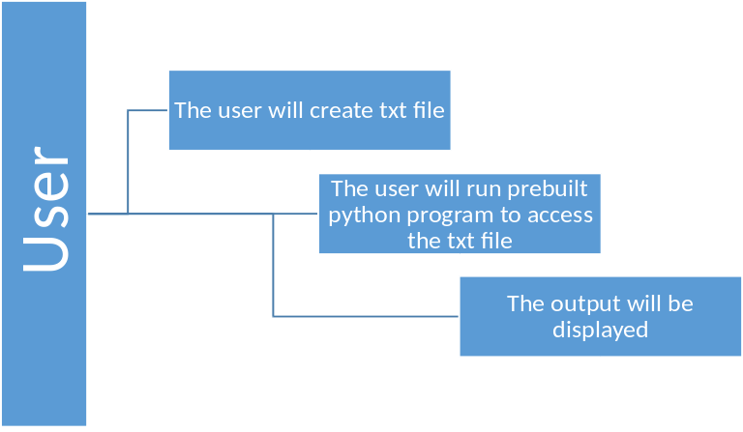

3.3.2 Use Case #2
The program is accessing the txt file
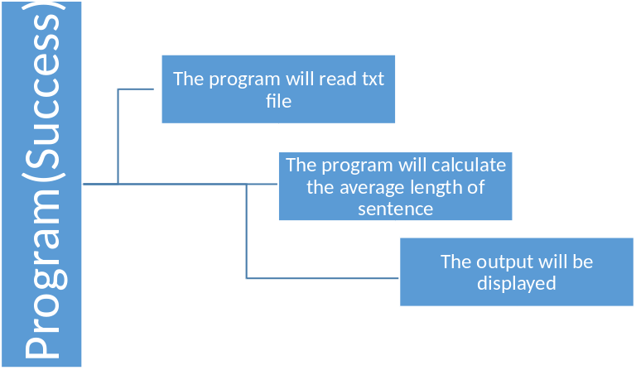

3.3.3 Use Case #3
The program accesses the file and the calculation fails.
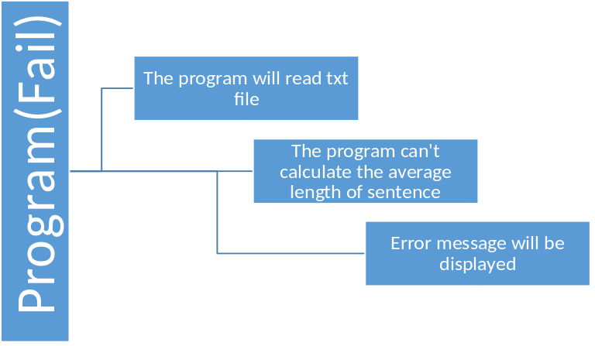

3.5 Non-Functional Requirements

3.5.1 Performance
System should output a report for an up to 50,000-character essay within 3 seconds 95% of the time.

System should output reports both to the command display and to a text file for batch processing.

3.5.2 Reliability
System should not crash when given arbitrary input.

3.5.3 Availability
System should be available for use at any time once installed locally on the user’s system. System should output a report after correct input with no additional user input.

3.5.4 Security
System should not open any security vulnerabilities on the platform.

3.5.5 Maintainability
System should not require future updates within the next 10 years, and should not contain any bugs.

3.5.6 Portability
System should operate on any operating system given the constraint (Python), and should not rely on the presence of third-party files or programs to function.

3.8 Logical Database Requirements
No database will be required for this system.

